## WORKSHEET 1:

**Student Name: Sahul Kumar Parida UID: 20BCS4919**

**Branch: CSE Section/Group - B**

**Semester: 5th Date of Performance: 2nd Aug 2022 Subject Name: Web and Mobile Security Subject Code: 20CST-333**

# Aim of the Practical:

Open any website on computer system and identify HTTP packet on monitoring tool like Wireshark.

## Objective of the Practical:

To analyze HTTP Traffic

## Software/Hardware Requirements:

Windows 7 & above version

## Tools to be used:

1. Wireshark Packet Sniffer and Packet Capture Library
2. Microsoft Word.
3. Win Zip as necessary

## Steps/Method/Coding:

* 1. Install Wireshark
  2. Open your Internet browser.
  3. Clear your browser cache.
  4. Open Wireshark.
  5. Click on "Capture > Interfaces". A pop-up window will display.
  6. You'll want to capture traffic that goes through your ethernet driver. Click on the Start button to capture traffic via this interface.
  7. Visit the URL that you wanted to capture the traffic from.
  8. Go back to your Wireshark screen and press Ctrl + E to stop capturing.
  9. After the traffic capture is stopped, please save the captured traffic into a

*.pcap format file and attach it to your support ticket.

## Output screenshot :

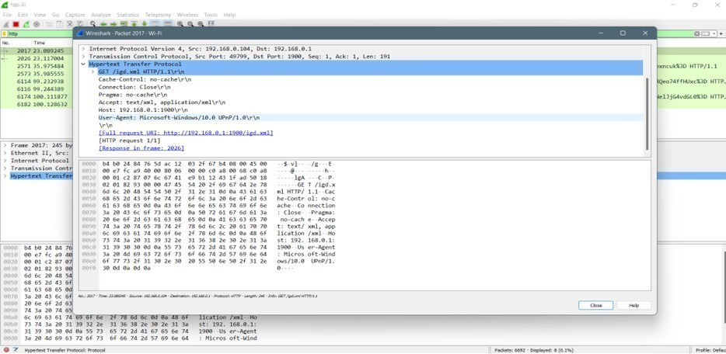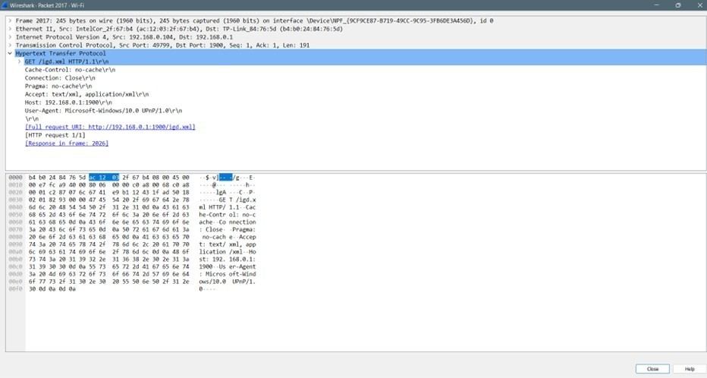

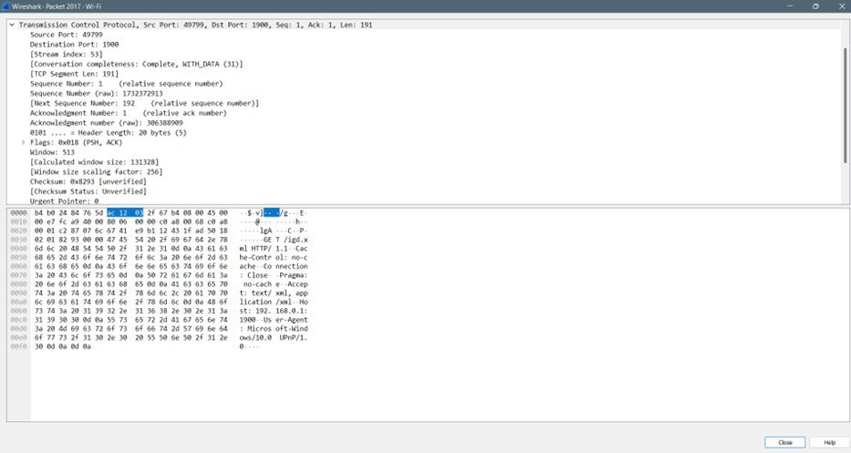

**Learning Outcomes:**

1. I learnt about HTTP protocol
2. I learnt about Web servers.